Attribute Finder Tutorial – Swiping Basics

Introduction
This is a tutorial demonstrating how the implementation of “swiping” or “highlighting” of text can be managed within an image window. UCLID Attribute Finder technology provides location information for the swipe and this information can be used to visually indicate position within the source document. The interfaces used to provide this location information will be described. A simple Visual C++ application that highlights text found in an image will be constructed.

Relevant Interfaces
This portion of the tutorial provides brief descriptions of the properties and methods of the interfaces used in highlighting text.

Name | Description
IOCRUtils::  RecognizeTextInZone() | Method that returns an ISpatialString object containing the text recognized within the provided IRasterZone
IRasterZone::  StartX  StartY | Properties that define the start point of the zone in pixels
IRasterZone::  EndX  EndY | Properties that define the end point of the zone in pixels
IRasterZone::  Height | Property that defines height of the zone in pixels
ISpatialString::  String | Property that defines the character string without any spatial information
IUCLIDComponentLM::  InitializeFromFile() | Method that reads the specified license file, decrypts the license data using the provided passwords, and stores licensing information for UCLID COM objects

Application Creation
This portion of the tutorial will step through the application wizard and create a simple application.

- Visual C++ App-Wizard. Start by creating a new project. Select the MFC AppWizard (exe) option. For this example, the location is the “…\Documentation\Tutorials\Swiping” directory and the project name is Swiping.

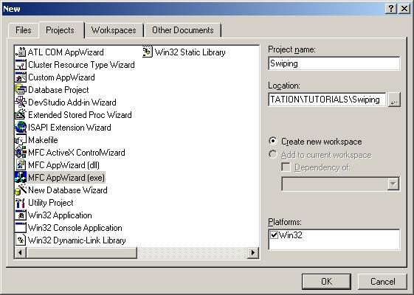

- Create a dialog-based application.

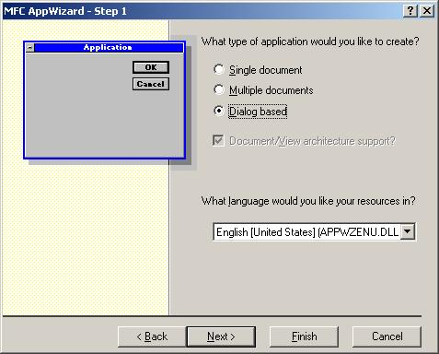

- The default features are sufficient. For this example, the About box was removed as unnecessary. Automation support is not needed. Support for ActiveX controls may be required in later tutorials.

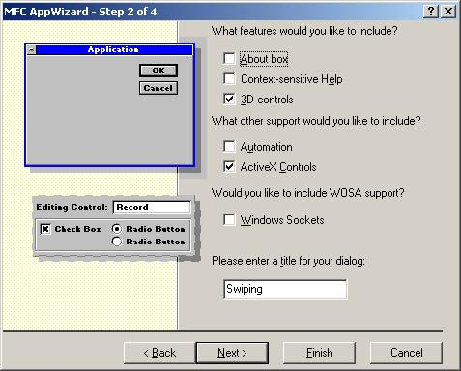

- The remaining default choices are sufficient.

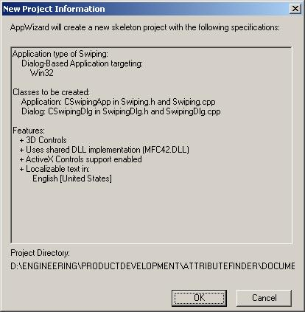

Populating the Dialog
This portion of the tutorial will populate the dialog with static text, edit boxes, a static image control, a spinner and buttons. The general arrangement of the controls is shown. ID values are suggested for the controls to allow better alignment with code snippets and subsequent tutorials.

- Remove static text and Cancel button. Move the OK button to the bottom right corner of the dialog.

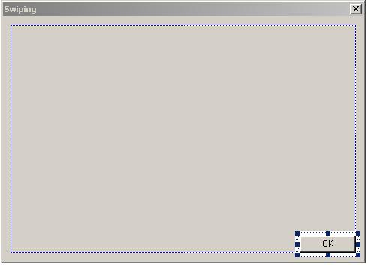

- Add static text labels for the upcoming edit boxes. The default ID of IDC_STATIC can be retained.

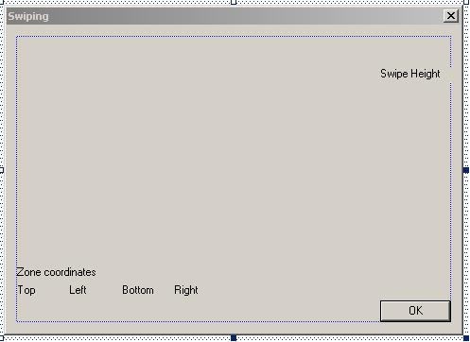

- Add edit boxes. The suggested ID’s are IDC_EDIT_TOP, IDC_EDIT_LEFT, IDC_EDIT_BOTTOM, IDC_EDIT_RIGHT, and IDC_EDIT_HEIGHT. Note that the edit boxes are read-only.

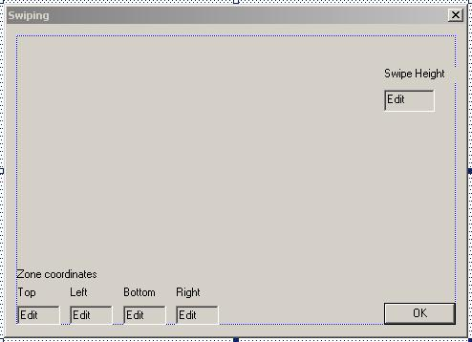

- Add a picture control and a spin control. The picture control (IDC_STATIC_IMAGE) is of type Bitmap with Border and Center Image styles. The spin control (IDC_SPIN_HEIGHT) has Vertical orientation and Right alignment. The spin control Style is Arrow keys plus Set buddy integer.

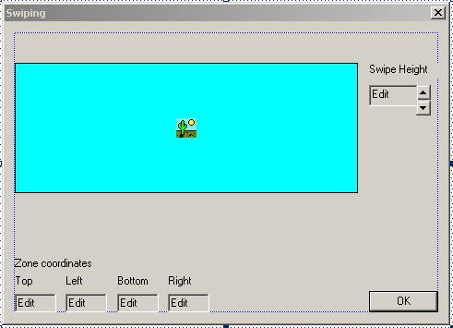

- Add buttons for Swipe and Clear. The Swipe button (IDC_BUTTON_SWIPE) will paint an area on the image based on the user’s mouse movements. The Clear button (IDC_BUTTON_CLEAR) removes the “swipe” from the display.

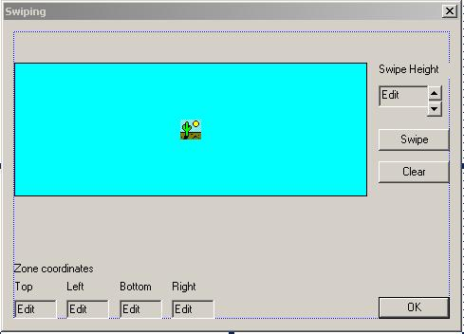

Coding the Dialog
This portion of the tutorial will add data members and message handlers. The image control will be initialized and mouse button messages will be used to display coordinate information. Last, a swipe will be painted on the image based on previous mouse movement. Note that code segments will be displayed in a different font with new code in bold.

- Using Class Wizard, add data members for the edit boxes, spinner, and image control.

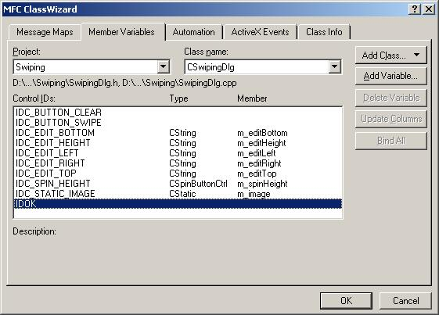
- Using Class Wizard, add mouse message handlers for CSwipingDlg to handle mouse down, mouse up, and mouse move.

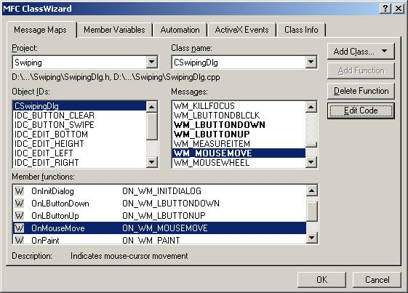
- Add BN_CLICKED message handlers for the Clear and Swipe buttons.

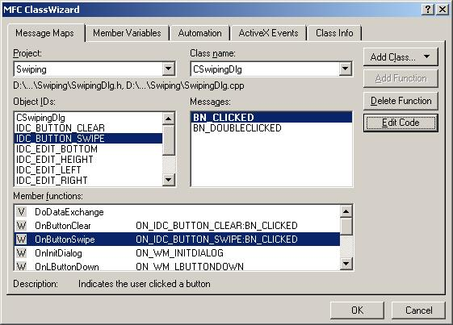
- Add an EN_UPDATE message handler for the Height edit box.

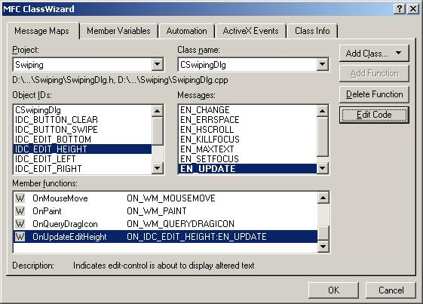
- Add code for data initialization. Add a class data member for Swipe height (m_iSwipeHeight). Set the spinner range and the default image file in OnInitDialog().

SetIcon(m_hIcon, FALSE); // Set small icon

// Load the default bitmap
HANDLE hbm;
hbm = ::LoadImage( NULL, _T("..\\Images\\NameAddress1.bmp"), IMAGE_BITMAP, 0, 0, LR_LOADFROMFILE );
m_image.SetBitmap( (HBITMAP)hbm );

// Setup spin control
m_spinHeight.SetBuddy( GetDlgItem( IDC_EDIT_HEIGHT ) );
m_spinHeight.SetRange( 10, 50 );
m_spinHeight.SetPos( 10 );

// Initialize height of swipe to spinner minimum
m_iSwipeHeight = 10;

return TRUE; // return TRUE unless you set the focus to a control

- Add code for update of swipe height when the spinner is modified.

void CSwipingDlg::OnUpdateEditHeight()
{
// Update the swipe height data member
m_iSwipeHeight = atol( m_editHeight.operator LPCTSTR() );
UpdateData( TRUE );
}

- Add message handlers for mouse down, mouse up, and mouse move. The zone coordinate edit boxes will be updated with start and stop mouse positions. Appropriate data members for start position, stop position, and mouse clicked are also added.

void CSwipingDlg::OnLButtonDown(UINT nFlags, CPoint point)
{
// Get position of image window
CRect rectImage;
m_image.GetWindowRect( &rectImage );

// Get mouse position
GetCursorPos( &point );

// Check to see if click in image window
if ((point.x >= rectImage.left) && (point.x <= rectImage.right) &&
(point.y >= rectImage.top) && (point.y <= rectImage.bottom))
{
// First clear the edit boxes
m_editTop = "";
m_editBottom = "";
m_editLeft = "";
m_editRight = "";
UpdateData( FALSE );

// Convert screen location to position within CStatic
m_image.ScreenToClient( &point );

// Display x, y in top, left edit boxes
CString zTemp;

zTemp.Format( "%d", point.y );
m_editTop = zTemp;

zTemp.Format( "%d", point.x );
m_editLeft = zTemp;

// Refresh display
UpdateData( FALSE );

// Set flag and store point
m_bMouseClicked = true;
m_ptStart = point;
}

CDialog::OnLButtonDown(nFlags, point);
}

void CSwipingDlg::OnLButtonUp(UINT nFlags, CPoint point)
{
// Get position of image window
CRect rectImage;
m_image.GetWindowRect( &rectImage );

// Get mouse position
GetCursorPos( &point );

// Check to see if click in image window
if ((point.x >= rectImage.left) && (point.x <= rectImage.right) &&
(point.y >= rectImage.top) && (point.y <= rectImage.bottom))
{
// Convert screen location to position within CStatic
m_image.ScreenToClient( &point );

// Display x, y in bottom, right edit boxes
CString zTemp;

zTemp.Format( "%d", point.y );
m_editBottom = zTemp;

zTemp.Format( "%d", point.x );
m_editRight = zTemp;

// Refresh display
UpdateData( FALSE );
}

// Clear flag
m_bMouseClicked = false;

// Store point from bottom and right edit boxes
m_ptStop.x = atol( m_editRight.operator LPCTSTR() );
m_ptStop.y = atol( m_editBottom.operator LPCTSTR() );

CDialog::OnLButtonUp(nFlags, point);
}

void CSwipingDlg::OnMouseMove(UINT nFlags, CPoint point)
{
// Get position of image window
CRect rectImage;
m_image.GetWindowRect( &rectImage );

// Get mouse position
GetCursorPos( &point );

// Check to see if click in image window
if ((point.x >= rectImage.left) && (point.x <= rectImage.right) &&
(point.y >= rectImage.top) && (point.y <= rectImage.bottom))
{
// Just return if mouse has not been clicked yet
if (!m_bMouseClicked)
{
return;
}

// Convert screen location to position within CStatic
m_image.ScreenToClient( &point );

// Display x, y in bottom, right edit boxes
CString zTemp;

zTemp.Format( "%d", point.y );
m_editBottom = zTemp;

zTemp.Format( "%d", point.x );
m_editRight = zTemp;

// Refresh display
UpdateData( FALSE );
}

CDialog::OnMouseMove(nFlags, point);
}

- Add code for the Swipe button. Code is also needed to calculate the region and set the zone bounds.

void CSwipingDlg::OnButtonSwipe()
{
// Get the device context pointer of the image window
CDC* pDC = m_image.GetDC();

// Set the highlight color to cyan
COLORREF zoneColor = RGB( 255, 0, 0 );

// Create a brush object
CBrush highltBrush;
highltBrush.CreateSolidBrush( zoneColor );

// Select brush object
CBrush *pOldBrush = (CBrush*)pDC->SelectObject( highltBrush );

// Set Draw mode
pDC->SetROP2( R2_XORPEN );
pDC->SetBkMode ( TRANSPARENT );

// Calculate the new region
calculateRegion();

// Fill the region
pDC->FillRgn( &m_zoneRegion, &highltBrush );

// Release the DC and delete the brush created
m_image.ReleaseDC( pDC );
highltBrush.DeleteObject();
}

- Add code for calculateRegion() and setZoneBounds(). Note that data members for an array of 4 CPoint objects (m_aptZoneBounds[4]) and a CRgn (m_zoneRegion) are required. The math.h header file is also required.

void CSwipingDlg::calculateRegion()
{
// Delete the region if exists
m_zoneRegion.DeleteObject();

// Compute the array of points that define the swiping region
setZoneBounds( m_ptStart.x, m_ptStart.y, m_ptStop.x, m_ptStop.y, m_iSwipeHeight );

// Create and display the region from the array of vertices
m_zoneRegion.CreatePolygonRgn( &(m_aptZoneBounds[0]), 4, ALTERNATE );
}

void CSwipingDlg::setZoneBounds(double x1, double y1, double x2, double y2, long lHeight)
{
// Calculate the zone vertices. The zone is a rectangular
// bounding box which has a color. It is referenced as zone
// rather than rectangle as it may be at an angle to highlight
// angular text.
//
// (0,0) *-----------------------* (1,1)
// | |
// zone start point + + zone end point
// | |
// (3,3) *-----------------------* (2,2)
//
// The zone is symmetric about the line joining the start and end
// points. The 4 vertices of the zone are dependent on the angle
// of the line joining the start and end points of the zone. The
// actual height of the zone is always 1 pixel less than the
// m_lHeight value which is in image pixels.

// Calculate the angle of the line dy/dx
double dAngle = atan2( y2 - y1, x2 - x1 );

// Update the vertices based on the rotation angle, the
// highlighting should be in rectangular shape symmetric about
// the line joining the start point and end point of the zone.

m_aptZoneBounds[0].x = (long)(x1 - ((lHeight/2) * sin (dAngle)));
m_aptZoneBounds[0].y = (long)(y1 + ((lHeight/2) * cos (dAngle)));

m_aptZoneBounds[1].x = (long)(x2 - ((lHeight/2) * sin (dAngle)));
m_aptZoneBounds[1].y = (long)(y2 + ((lHeight/2) * cos (dAngle)));

m_aptZoneBounds[2].x = (long)(x2 + ((lHeight/2) * sin (dAngle)));
m_aptZoneBounds[2].y = (long)(y2 - ((lHeight/2) * cos (dAngle)));

m_aptZoneBounds[3].x = (long)(x1 + ((lHeight/2) * sin (dAngle)));
m_aptZoneBounds[3].y = (long)(y1 - ((lHeight/2) * cos (dAngle)));
}

- Add code for the Clear button. In a production application the positions of each highlighted zone would be saved and repainted when the window was refreshed. Since this highlight is not stored, a simple refresh restores the original image.

void CSwipingDlg::OnButtonClear()
{
// Just repaint the image
m_image.Invalidate( TRUE );
}

- Test the application by clicking the mouse to the left of and dragging across “Name”.

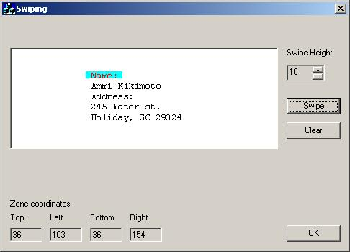

- Increase the swipe height to 25 and swipe the word “Address”.

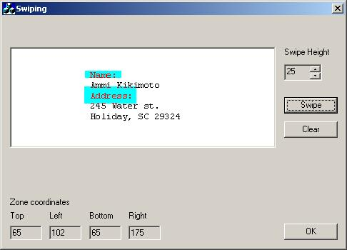

Extending the Dialog
This portion of the tutorial will add loading of user-specified images plus display of OCR results to a new edit box. Licensing requirements must also be addressed when adding OCR capability.

- Add an edit box (IDC_EDIT_IMAGE) and Browse button (IDC_BUTTON_BROWSE) for image files. Add a multi-line edit box for OCR output (IDC_EDIT_OCR). Add an OCR button (IDC_BUTTON_OCR). Note that a label has also been added for the image edit box.

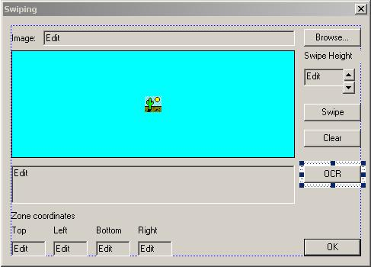

- Using Class Wizard, add data members for the new edit boxes (m_editImage and m_editOCR) and BN_CLICKED message handlers for the Browse and OCR buttons.

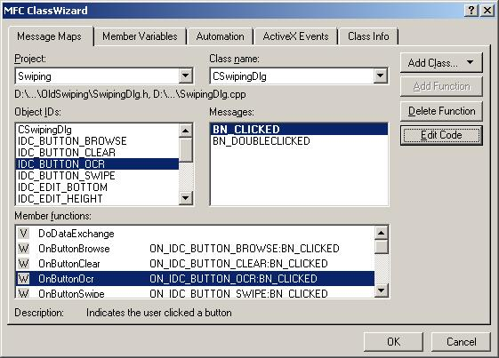
- Add initialization of the COM libraries within CSwipingApp::InitInstance().

// Initialize the COM libraries
CoInitialize( NULL );

{
CSwipingDlg dlg;
m_pMainWnd = &dlg;
int nResponse = dlg.DoModal();
if (nResponse == IDOK)
{
// TODO: Place code here to handle when the dialog is
// dismissed with OK
}
else if (nResponse == IDCANCEL)
{
// TODO: Place code here to handle when the dialog is
// dismissed with Cancel
}
}

// Release the COM libraries
CoUninitialize();

- Add a local License Manager object (ipLicense) and initialize the license within OnInitDialog(). Note that a valid license file with associated passwords is required.

BOOL CSwipingDlg::OnInitDialog()
{
CDialog::OnInitDialog();

// Declare license object
IUCLIDComponentLMPtr ipLicense( __uuidof(UCLIDComponentLM) );

// TODO: Initialize license object with valid file and 4 passwords
ipLicense->InitializeFromFile( "Insert filename here!!!", 1, 2, 3, 4 );

// Set the icon for this dialog. The framework does this automatically
// when the application's main window is not a dialog
...

- Add code for the Browse button.

void CSwipingDlg::OnButtonBrowse()
{
// Create and display a File Open dialog
CFileDialog fileDlg( TRUE, ".bmp", m_editImage,
OFN_HIDEREADONLY | OFN_FILEMUSTEXIST | OFN_PATHMUSTEXIST,
"Bitmap files (*.bmp)|*.bmp|"
"Cursor files (*.cur)|*.cur|"
"Icon files (*.ico)|*.ico|"
"All files (*.*)|*.*||", NULL );

if (fileDlg.DoModal() == IDOK)
{
// Get file name
CString zFile = fileDlg.GetPathName();

// Load image
HANDLE hbm;
hbm = ::LoadImage( NULL, zFile, IMAGE_BITMAP,
0, 0, LR_LOADFROMFILE );

if (hbm != NULL)
{
m_image.SetBitmap( (HBITMAP)hbm );

// Update filename member
m_editImage = zFile;
UpdateData( FALSE );
}
}
}

- Add #import statements for the DLLs required to support OCR.

#import "COMLM.dll"
using namespace UCLID_COMLMLib;

#import "UCLIDCOMUtils.dll"
using namespace UCLIDCOMUTILSLib;

#import "UCLIDRasterAndOCRMgmt.dll"
using namespace UCLID_RASTERANDOCRMGMTLib;

- Modify the project settings and add an additional #include directory.

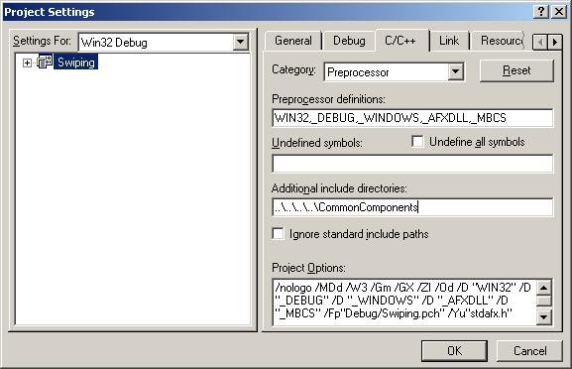
- Add code for the OCR button. An IRasterZone object is created with the swiped coordinates. The IOCRUtils object is used to recognize the text in the zone. The IOCRUtils object may be created once in OnInitDialog() and then reused through the life of the application.

void CSwipingDlg::OnButtonOcr()
{
// Create the IRasterZone object
IRasterZonePtr ipZone( __uuidof(RasterZone) );

// Set the coordinates and the height
ipZone->StartX = m_ptStart.x;
ipZone->StartY = m_ptStart.y;
ipZone->EndX = m_ptStop.x;
ipZone->EndY = m_ptStop.y;
ipZone->Height = m_iSwipeHeight;

// Create an IOCRUtils object to recognize the text
// inside the "swiped" zone
IOCRUtilsPtr ipOCRUtils( __uuidof(OCRUtils) );
ISpatialStringPtr ipText = ipOCRUtils->RecognizeTextInZone(
ipZone );

// Update the display
if (ipText != NULL)
{
m_editOCR = ipText->GetString();
UpdateData( FALSE );
}
}

Further Efforts
This section will briefly describe additional enhancements to the dialog. These will be left as exercises for the student.

- Store the swiped zones as a collection of IRasterZone objects. Add code to repaint them when the CStatic control is refreshed.

- Paint the current “swipe” during OnMouseMove(). This provides visual feedback to the user about swipe height and orientation.

- Replace the CStatic control with another image control that supports zooming, panning, and other operations.

